Name: |  | Date:
 | Year 7 Mathematics  Term 1, 2022  Fractions Investigation  Resources Allowed:  Calculators, pen, pencil | Total Marks:

Scenario:
Use this map of Australia (below) to estimate the size of each State or Territory as a fraction of Australia.

Compare each state as a fraction of Western Australia and discuss your reasoning for your findings.
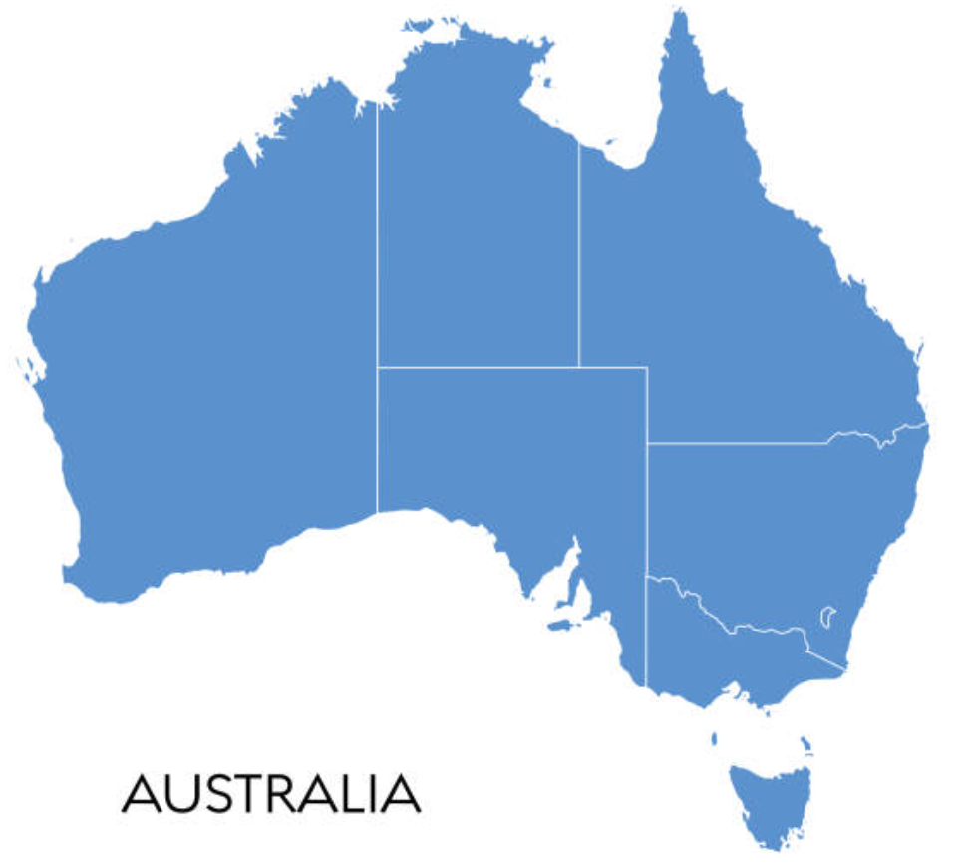

Example of response/setting out. Teacher to use this as a guide to assist and scaffold. Do not show (project on projector) students these exact questions as there could be various ways students could answer the scenario.

Question 1: What fraction of Australia is the state of Western Australia ? (2 Marks)

- Must write in fraction form
- $\frac{1}{3}$approx

Question 2: Write about how you used your knowledge of fractions and estimating to get your answer.
- A number of reasonable responses
  - Fitting in Vic into each state
  - Gridding up the whole country

Question 3: What fraction of Australia is the state of Victoria and explain how you got your answer?

- $\frac{1}{30}$approx and see responses in Q2

Question 4: What fraction of Western Australia is the state of New South Wales? Include an explanation of your mathematical thinking

- $\frac{1}{3}$approx and see responses in Q2 but must have evidence of having used WA as denominator

Question 5: Gemma and Adi disagree on which fraction is larger $\frac{1}{4}$ or $\frac{1}{5}$. Describe how number lines can be used to compare the fractions and decide which is larger.

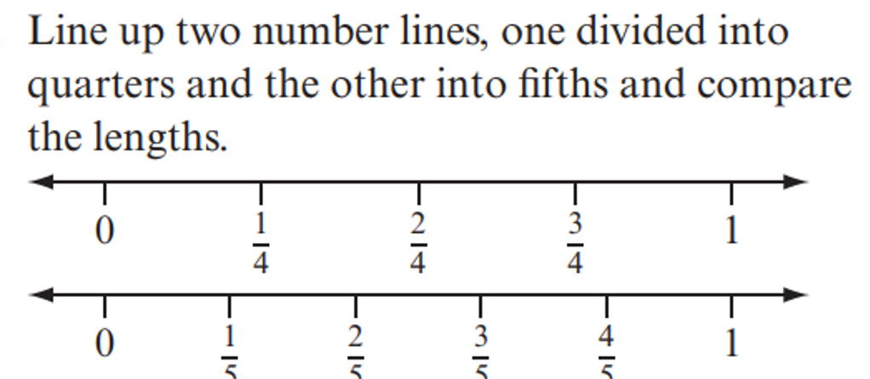

Marking Rubric Fractions Investigation

Question 1 | Answer in fraction form  Answer reasonable | 2 marks
Question 2 | Reasonable response provided  Details/diagram/stepwise response | 2 marks
Question 3 | Answer reasonable  Reasonable response provided  Details/diagram/stepwise response | 3 marks
Question 4 | Answer reasonable  Reasonable response provided noting WA as denominator  Details/diagram/stepwise response | 3 marks
Question 5 | Answer correct  Reasonable response provided  Details/diagram/stepwise response | 3 marks

